EASTERN INTERNATIONAL UNIVERSITY | Practice Assignment – Quarter 4, 2025- 2026
SCHOOL OF COMPUTING  AND INFORMATION TECHNOLOGY | Course Name: ISAD  Course Code: CSW 309
Student’s Full Name: Vũ Đức Tùng
Student ID: 2331200132

LAB 06
High-Level Design, Low-Level Design, UML, BPMN & Database Design

2. Scenario: University Facility Booking System
Students and lecturers can submit facility booking requests for classrooms, meeting rooms, and laboratories. A requester selects a facility, booking date, start time, end time, purpose, and expected number of participants. The system checks basic input validity and records the request as Pending. Staff members review pending requests, check facility availability and service rules, then approve or reject each request. The system sends a notification to the requester after submission and after the staff decision.
Each facility has a facility ID, facility name, location, capacity, facility type, and status. A booking request has a request ID, requester, facility, booking date, start time, end time, purpose, participant count, request status, and submission time. A staff decision records who reviewed the request, decision date, decision result, and decision note. Approved requests become booking records. The office wants to keep request history, avoid overlapping bookings for the same facility and time period, and support basic reporting on booking requests by date, facility, status, and requester type.
For this lab, students should focus on analysis-to-design consistency. The same case should be used across HLD, LLD, UML, BPMN, and database design.

3. Requirements
Complete the following tasks. This lab is focused on HLD, LLD, UML, BPMN, and Database Design.

Task 1 - High-Level Design
Prepare a High-Level Design for the University Facility Booking System. HLD should show the big-picture structure of the system, not the detailed workflow steps.
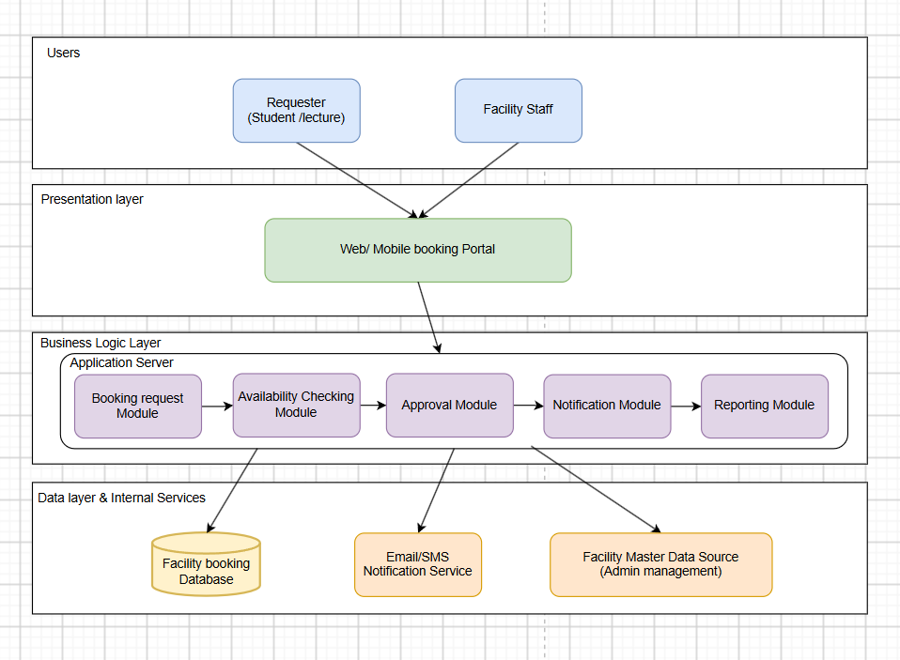
Major Modules / Components and Responsibilities
Module | Responsibility | Input | Output
Booking Request Module | Create and manage facility booking requests; record initial status as Pending. | RequesterID, FacilityID, BookingDate, StartTime, EndTime, Purpose, ParticipantCount | RequestID, RequestStatus
Availability Checking Module | Check facility availability and detect overlapping bookings for a given date/time. | FacilityID, BookingDate, StartTime, EndTime | AvailabilityStatus, ConflictingBookingID
Approval Module | Support staff review, apply service rules, approve/reject requests, and create booking records. | RequestID, StaffID, DecisionResult, DecisionNote | RequestStatus, BookingID
Notification Module | Send a notification to the requester after submission and after the staff decision. | RequesterID, RequestID, Status, MessageContent | NotificationStatus
Reporting Module | Generate booking reports by date, facility, status, and requester type. | Report filters (date range, facility, status) | Report data / export
Facility Management Module | Maintain facility master data (ID, name, location, capacity, type, status). | FacilityID, FacilityName, Location, Capacity, FacilityType | Facility record confirmation

Module Communication
Users access the system only through the Web/Mobile Booking Portal (presentation layer); they never access the database directly. The Booking Request Module receives new requests from the portal and stores them with status Pending. When a Facility Staff member opens a request in the Approval Module, the Approval Module calls the Availability Checking Module to verify that the requested facility, date, and time do not overlap with an existing approved booking. After a decision is made, the Approval Module updates the request status, creates a booking record when approved, and calls the Notification Module so the requester is informed. The Reporting Module reads data independently to produce booking reports, and the Facility Management Module maintains the facility master data used by the other modules.

Major Data Groups and External Systems
Major data groups: Facility data (facility ID, name, location, capacity, type, status), Booking Request data (request ID, requester, facility, date/time, purpose, participant count, status, submission time), Staff Decision data (reviewer, decision date, result, note), and Booking data (confirmed bookings). External systems: an Email/SMS Notification Service is used to deliver submission and decision notifications to requesters.

Justification
This layered design is suitable because it keeps the booking business rules (availability checking, approval workflow) inside the Business Logic Layer, separated from the user interface and the database. It matches the scenario requirement to avoid overlapping bookings, since the Availability Checking Module verifies this centrally before any request is approved. It also supports the required reporting by date, facility, status, and requester type through a dedicated Reporting Module, and keeps notification delivery decoupled through an external service so it can be scaled or replaced independently of the core booking logic.

Task 2 - Low-Level Design
Prepare a Low-Level Design for one selected component. Recommended component: Booking Approval Component. This component supports staff review, availability checking, approval/rejection, booking creation, status update, and notification
1. Component Specification
Design Item | Content
Component Name | Booking Approval Component
Purpose | Support staff review of pending booking requests, check facility availability, approve or reject requests, create booking records, update request status, and trigger notification.
Related Use Case | Approve Facility Booking Request
Input Data | RequestID, StaffID, DecisionResult, DecisionNote
Output Data | RequestStatus, BookingID (if approved), NotificationStatus
Data Stores / Entities Used | FACILITY, BOOKING_REQUEST, STAFF_DECISION, BOOKING
Other Components Called | Availability Checking Module, Notification Module
2. Internal Flow
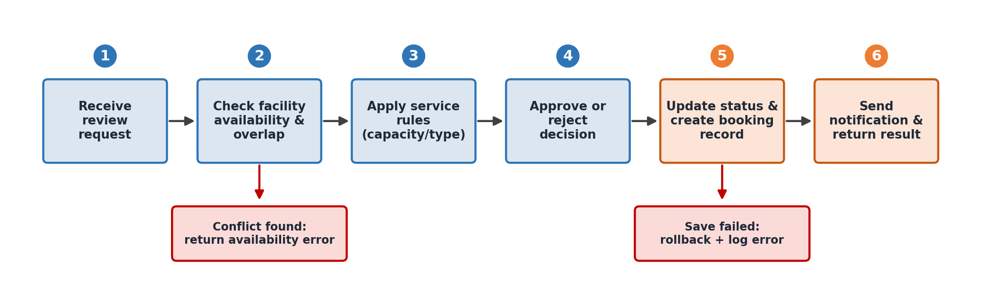
The internal flow shows six main steps inside the component: (1) receive the review request from staff, (2) check facility availability and overlap with existing approved bookings, (3) apply service rules such as capacity and facility-type match, (4) record the staff approve/reject decision, (5) update the request status and create a booking record when approved, and (6) send the notification and return the result to the staff interface. A conflict found in step 2 and a save failure in step 5 are handled as explicit error branches instead of silently terminating the component.

3. Processing Rules
ID | Condition | System Action | Design Implication
PR-01 | Staff opens a request with RequestStatus = Pending | Load request, facility, and requester details for review | Only pending requests can be reviewed; approved/rejected requests are read-only
PR-02 | Selected facility already has an approved booking overlapping the requested date/time | Block the approval and return a conflict message | Prevents double-booking of the same facility and time slot
PR-03 | Staff selects Approve and no conflict is found | Create a Booking record and set RequestStatus = Approved | Booking creation rule; a booking always originates from an approved request
PR-04 | Staff selects Reject | Set RequestStatus = Rejected and require a DecisionNote | Status transition rule; a reason must be recorded for rejection
PR-05 | A staff decision (Approve or Reject) has been saved | Call the Notification Module through the interface contract to inform the requester | Interface contract call; keeps notification logic outside the Approval Module
PR-06 | RequestStatus is already Approved or Rejected | Prevent staff from submitting a new decision on the same request | Terminal business outcome; enforces a valid status transition

4. Validation Rules
ID | Field / Condition | Validation Rule | Error Message | Where Enforced
V1 | DecisionResult | Must be Approve or Reject; cannot be empty | "Please select Approve or Reject." | Approval Module
V2 | DecisionNote | Required when DecisionResult = Reject | "Please provide a reason for rejection." | Approval Module
V3 | RequestID | Must exist and have RequestStatus = Pending | "This request is no longer pending." | Approval Module
V4 | StaffID | Must belong to an authenticated Facility Staff account | "Access denied. Please log in as facility staff." | Authentication layer
V5 | FacilityID + BookingDate + StartTime + EndTime | Must not overlap an existing approved booking for the same facility | "Selected time slot is already booked." | Availability Checking Module
V6 | ParticipantCount | Must not exceed the facility's Capacity | "Number of participants exceeds facility capacity." | Approval Module

5. Interface Contract
Item | Specification
Operation | checkFacilityAvailability(facilityId, bookingDate, startTime, endTime)
Source | Approval Module
Target | Availability Checking Module
Input | FacilityID, BookingDate, StartTime, EndTime
Output | AvailabilityStatus (Available / Conflict), ConflictingBookingID (if any)
Precondition | RequestStatus = Pending and the facility exists
Postcondition | An availability result is returned; no booking data is changed
Error Cases | Facility not found; invalid time range (EndTime is earlier than or equal to StartTime)
Security | Only authenticated internal modules can call this operation

6. Error Handling
Code | Error Case | User Message | System Action | Result
E01 | Request already decided | "This request has already been processed." | Reject the new decision attempt; keep existing status | Stop
E02 | Facility conflict detected | "Selected time slot is already booked. Please choose another slot or reject the request." | Keep RequestStatus = Pending; log the conflict | Stop
E03 | Database save failure when creating booking / updating status | "The decision could not be saved. Please try again." | Roll back the transaction; log the error with a trace ID; alert support | Rollback
E04 | Notification send failure | "Decision saved, but notification delivery is pending." | Save the notification as Pending/Failed and retry later | Continue

7. Controls
Control | Example in the Booking Approval Component
Authentication | Facility staff must log in with a valid staff account before reviewing requests.
Authorization | Only the Facility Staff role can approve or reject; a requester cannot approve their own request.
Audit Log | Store StaffID, DecisionDate, DecisionResult, and DecisionNote for every decision.
Data Integrity | Foreign key constraints between BOOKING_REQUEST, FACILITY, STAFF_DECISION, and BOOKING; the availability check is enforced before insert.

Task 3 - UML Modeling
Create UML diagrams that support the design of the University Facility Booking System. The diagrams must be consistent with the HLD and LLD decisions.
Class Diagram
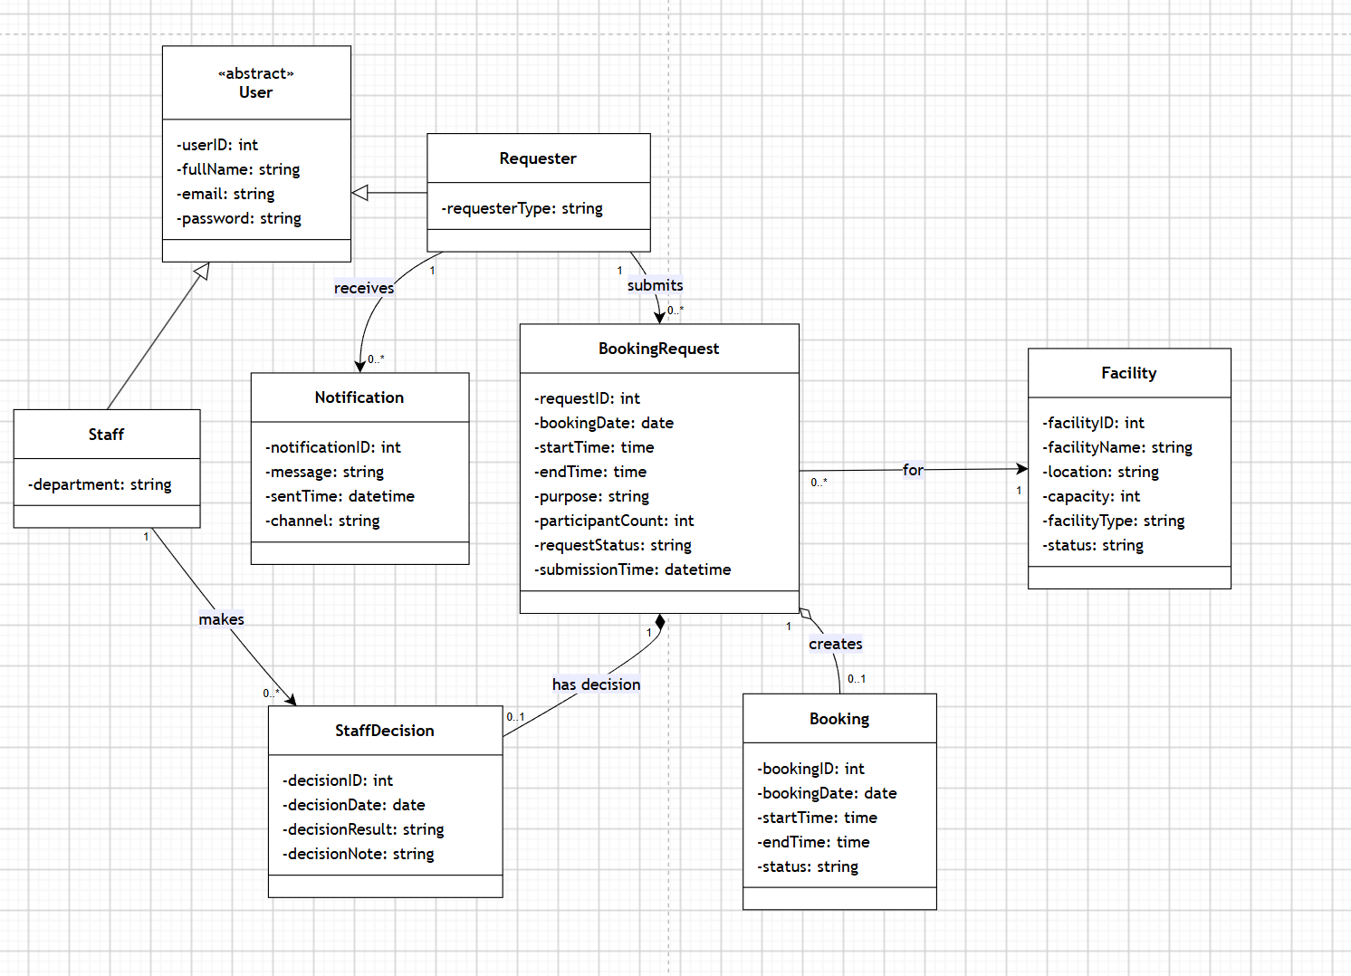
The class diagram includes eight domain classes: User (abstract), Requester, Staff, Facility, BookingRequest, StaffDecision, Booking, and Notification. Requester and Staff inherit from the abstract User class (generalization). BookingRequest has a composition relationship with StaffDecision, since a decision cannot exist without the request it belongs to, and an aggregation relationship with Booking, since a booking record is created from an approved request but represents a separate, independently referenced object.

Sequence Diagram - Approve Facility Booking Request
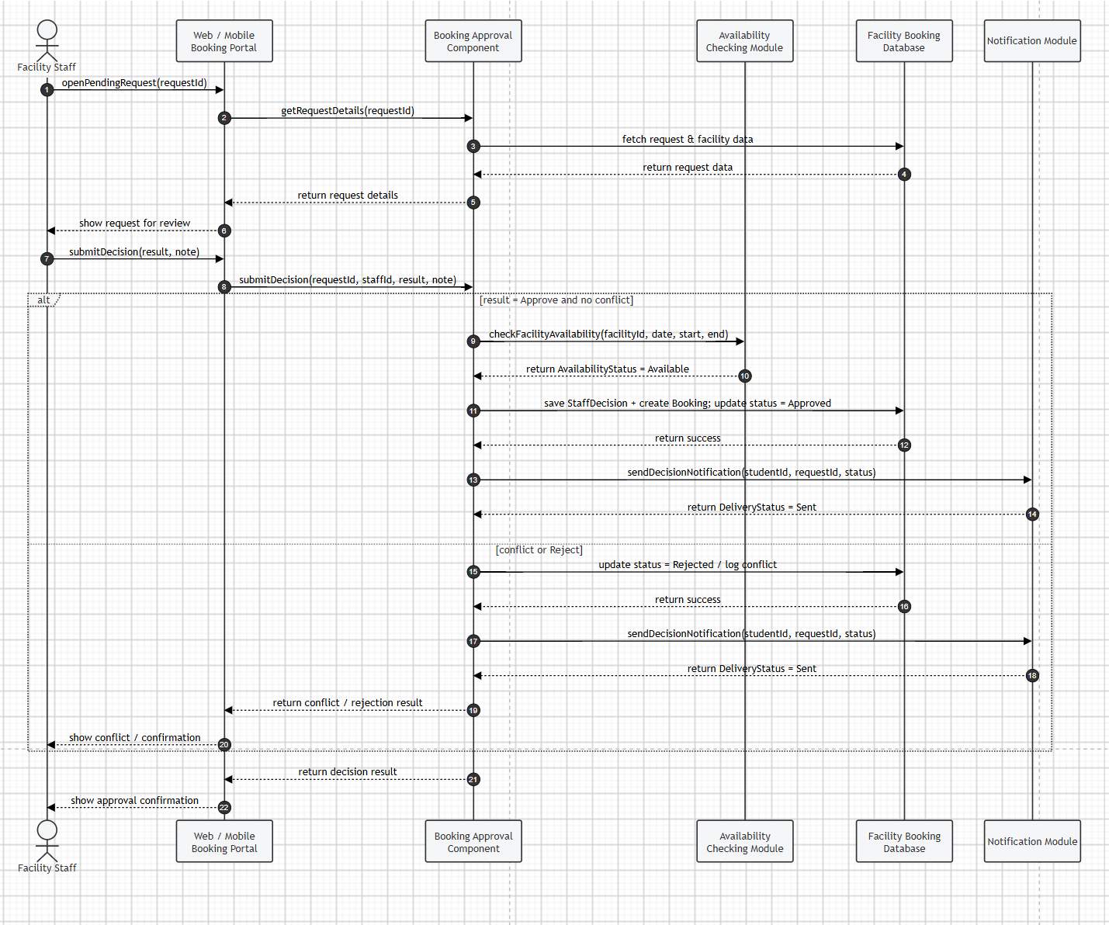
Figure 4. UML Sequence Diagram - Approve Facility Booking Request
The sequence diagram shows Facility Staff, the Web/Mobile Booking Portal, the Booking Approval Component, the Availability Checking Module, the Facility Booking Database, and the Notification Module. After staff submit a decision, the alt fragment separates two cases:
- If the request is approved and no conflict exists, the system creates a booking record, updates the status, and sends a notification to the requester.
- If a conflict is found or the request is rejected, the system updates the status and logs the decision without creating a booking, but still sends a notification to inform the requester before returning the final result to the staff interface.

Task 4 - Draw BPMN workflow
Draw a BPMN diagram for Facility Booking Approval.
The BPMN diagram should include:
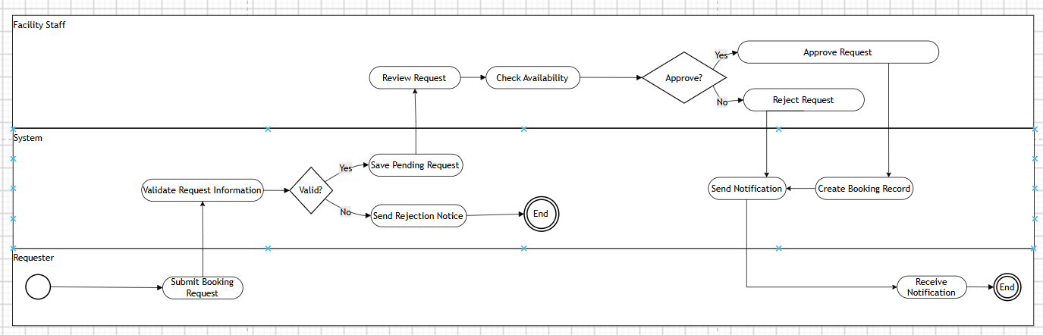
The BPMN diagram uses three lanes inside a single pool (Requester, System, Facility Staff). The Requester submits a booking request; the System validates the request and, if invalid, sends a rejection notice and the process ends. If valid, the request is saved with status Pending and routed to Facility Staff for review. Facility Staff check availability and either approve or reject the request; approved requests trigger the System to create a booking record before sending the notification, while rejected requests go straight to the notification step. The Requester receives the notification and the process ends.

Task 5 - Map data model to logical tables
Map the main domain classes or Concept ERD elements to logical tables. Identify primary keys, foreign keys, important attributes, and the business purpose of each table.

Answer
Table Name | Primary Key | Foreign Key(s) | Important Attributes
FACILITY | FacilityID | - | FacilityName, Location, Capacity, FacilityType, Status
USER_ACCOUNT | UserID | - | FullName, Email, Password, Role (Requester/Staff), RequesterType, Department
BOOKING_REQUEST | RequestID | RequesterID (UserID), FacilityID | BookingDate, StartTime, EndTime, Purpose, ParticipantCount, RequestStatus, SubmissionTime
STAFF_DECISION | DecisionID | RequestID, StaffID (UserID) | DecisionDate, DecisionResult, DecisionNote
BOOKING | BookingID | RequestID, FacilityID | BookingID, RequestID , FacilityID và Status
NOTIFICATION | NotificationID | RequesterID (UserID), RequestID | Message, SentTime, Channel

Business Purpose of Each Table
- FACILITY - stores facility master data used for booking and availability checking.
- USER_ACCOUNT - stores login and identity data for both requesters and facility staff.
- BOOKING_REQUEST - records each booking request submitted by a requester and its current status.
- STAFF_DECISION - records the staff review decision (approve/reject) for one booking request.
- BOOKING - stores confirmed bookings that are created after a request is approved.
- NOTIFICATION - stores notifications sent to requesters after submission and after the staff decision.

Task 6- Identify constraints and business rules
Write database-related constraints and business rules that should be enforced or checked. Some rules may be implemented by database constraints, while others may require application logic.

Rule / Constraint | Related Table(s) | Reason
A booking request cannot be approved if the facility already has an approved booking overlapping the same date and time. | BOOKING_REQUEST, BOOKING | Prevents double-booking of the same facility and time slot.
RequestStatus must follow a valid transition: Pending -> Approved / Rejected only. | BOOKING_REQUEST | Keeps request status meaningful and auditable.
ParticipantCount must not exceed the Capacity of the selected facility. | BOOKING_REQUEST, FACILITY | Ensures the facility can physically accommodate the booking.
Every STAFF_DECISION record must reference a valid, existing BOOKING_REQUEST (foreign key constraint). | STAFF_DECISION, BOOKING_REQUEST | A decision cannot exist without the request it belongs to (data integrity).
A BOOKING record can only be created after a request has been Approved. | BOOKING, BOOKING_REQUEST | Bookings must always originate from an approved request, not directly from a pending one.
BookingDate, FacilityID, and RequestStatus should be indexed to support reporting by date, facility, status, and requester type. | BOOKING_REQUEST | Improves performance of the required booking reports.

4. Assessment (100 points total)
Task # | Criteria | Points
1 | HLD | 10
2 | LLD | 15
3 | UML modeling | 25
4 | BPMN workflow | 20
5 | Database design | 20
6 | Business rules and constraints | 10

5. Submission
Submit one PDF report and editable diagram/database design file(s). File name format: CSW309_Lab06_StudentNo_StudentName.

6. Notice for Student
- BPMN models the business process; it should not be identical to a sequence diagram.
- Database design should be based on entities/classes and business rules, not on screen layout.

